Progress Report 1

Hardware Project: Parts Crib Database

By: Masoud Rahguzar

Student #: n01036517

Course: CENG 317

Date: October, 11 2016

**Progress**

74% (approx.)

Incomplete

26% (approx.) Complete

0%

100%

Week 2: Individual Report – Completed

Week 3: Project Schedule – Completed

Week 4: Budget – Completed

Week 5, I have acquired the most of the equipment/parts such as Raspberry Pi 3 Ultimate Starter Kit (includes: HDMI Cable, Breadboard, Wires, LED lights, Ribbon Cable, and SD card), camera and barcodes (Through a website that creates barcodes). – 95% Completed

The progress so far completed for the hardware aspect of the project starts from week 2. Week 2 I decided on what project I would doing from the loT themed hardware project at <http://six0four.github.io/>. Then I proceeded on creating an Individual Report which consisted on, what my project is about, how I would make it and who would be working with me. Next, on week 3 I built a Project schedule that will consist on what I will be doing on each week for my hardware project and will help keep track of everything. Lastly, week 4 I created a budget based on what I’m supposed to buy for my project. Currently, during week 5 I have acquired most of the equipment/parts for my project and then proceed in the further weeks to actually building my hardware project. I also have completed my soldering for my PCB.

Throughout the weeks I haven’t yet encounter any problems so far because of the fact I have not yet actually built the software to run program and also have not put all the hardware parts together. This will be done in week 7 as seen in my project schedule.

So far my financial status is on track and completed don’t need any more parts because I have brought everything need.

Masoud Rahguzar

**Receipts**

Raspberry Pi 3 Ultimate Starter Kit

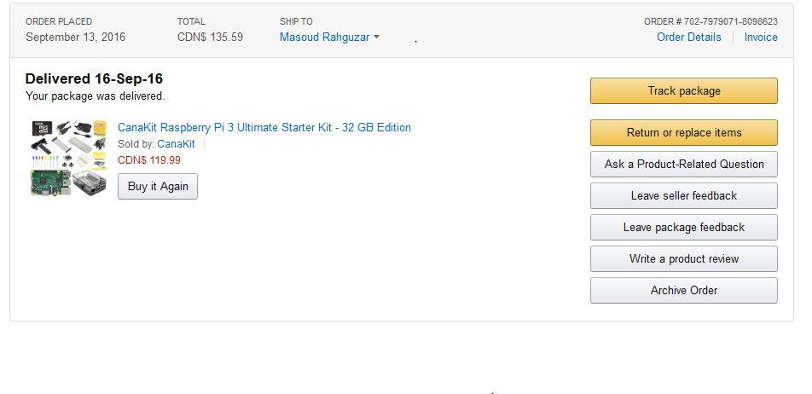

Includes – HDMI Cable, Breadboard, Wires, LED lights, Ribbon Cable, SD card and other parts/equipment.

Sample Barcodes



Part #

Student #

Camera

